Sprite page formatter

Purpose

I already have functionality built into my game development library for Sprite Sheets. Just to define, Sprite Sheets are image files setup in a grid format such that a row represents a character moving in a specific direction and the columns representing the different states that character might be in to show motion.

|  |  |
| --- | --- |
|  | For instance – this is a Spritesheet for pacman. Row 0 is moving right; 1 left; 2 up; and 3 down.  With this setup it is quite easy to select the right “row” from which to pull the proper image just by identifying which key the user pressed. Then you just rotate between the “columns” to give pacman motion.  The limitation with this is each “frame” is assumed to be the same size and also assume each “row” has the same number of frames to it. |

Now lets compare it to what I call a Sprite Page. A Sprite page is typically for a character that can have a lot more potential “actions”. In the case below, these are images of Bart Simpson ripped from the Simpson’s video game.

|  |  |
| --- | --- |
|  | This is a large image file, but it has a tons of actions Bart can do. Also note that not all the frames – even within a single action are the same size. |

My goal for this program is to be able to load a Sprite Page like this and help the user define a whole set of actions from it. These would be stored in some easy to read file ( csv, XML, JSON, whatever) – for now I’m just using CSV – but I actually think XML or JSON would be best since it is hierarchical. This program reads in the data file ( again – currently a CSV) and should write out one as well. The file looks for a png file with the same name to load.

This file would have a unique identifier for each action as well as each frame in the action. Each frame in turn would list its number in the series and its starting x & Y coordinated ( top left corner) as well as the bottom right X & Y coordinates.

As it currently works you can see that the mouse X&Y coordinates are shown to the user to help them pick the correct coordinates for each frame and the frames are shown “in motion” in the animateCanvas. This is to help the user see how their frames would look when used.

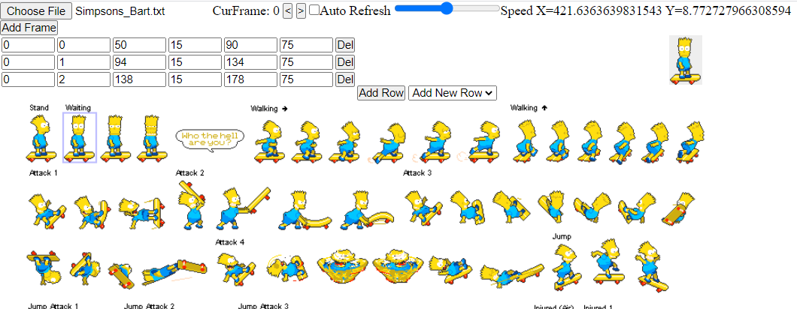

My thought is that each “action” is stored in an array and corresponding “frames” for that action are stored in a corresponding 2 dimensions array. Each added action could then be selected from a drop down list and once selected, its frames would appear for editing ( including adding and deleting frames). These changes would immediately be visible to the user via the animCanvas image.

Also note that the entire Sprite Page may not fit on the screen at a time, so it should probably be placed in some frame that has scrolling abilities.